TEACHING THE BLIND CHILD
By
N.Krishnaswamy IPS (Retd)
Chairman, Vidya Vrikshah

Teaching the blind child is much like teaching a normal child, except perhaps, that it calls for a deeper and more sensitive understanding of the learning and teaching process. As the child's first teacher, the mother's understanding has a depth and sensitivity that springs not only from practical commonsense, but also from the emotional attachment, commitment, concern and deeper instincts that are natural to any mother.

When the child moves on from the care of the mother and home to the care of the teacher and school, we assume that there is a natural extrapolation of, and building on, the wonderful strengths built in the earlier environment. We assume that the teacher will bring to bear additional scientific insights of child psychology and educational psychology that are to be expected from one who has been trained to be a school teacher. Perhaps this is true of a few exceptional teachers and schools, but unfortunately, is not true of many of them.

Let us focus here on the essentials of the learning and teaching process and first get the overall perspective right. In basic terms, this means, first, development of the cognitive potentials of the child, during the pre-school and primary school stage. This in turn means, development by training, of all the sensory skills that contribute to the cognitive processes, to levels from which later knowledge acquisition would proceed efficiently. That some of the sensory faculties are not available in some other-wise-able children, only stresses the need for the teacher to build on the skills that are available, and explore and exploit their compensatory role and potential.

An essential aspect of this overall perspective is that we need to retain a holistic view of the role and function of all skills in the teaching process, while not letting differences in individual skills lead us into over-emphasis on some and neglect of others. Nor should we let absence of some skills in children lead us into over-specializations in organization and method of the teaching system. It is the loss of a holistic view that has led to the unfortunate dichotomy that divides the educational system today into mainstream schools and special schools, and to the rise of the new class of special educators, apart from the class of general teachers. We are just beginning to realize that these divisive trends have perhaps gone too far, and that we need to remedy this with a movement towards integrated schools, and towards greater integration in the training skills of teachers. There is certainly need for specializations, but clearly these have to be applied only to those exceptional children, where it is not practicable or advisable to entrust them to the integrated arrangements. For instance, while blind or deaf children can and should be handled in mainstream schools, it would be necessary to send deaf-blind or mentally retarded children to special institutions or place them under specialist teachers.

The need for in-depth understanding of each sensory skill and of the inter-relationships of multiple skills requires special emphasis. Those who teach blind children, for instance, need to have a fuller understanding, not only of the sense of touch, but also the intimate relationship of the tactile skill to all the other sensory skills. Consider a blind child whose vision is so impaired that the world outside is one of total darkness. Even so, it may still build fairly vivid internal images of the external world from the variety of other sensory inputs. For instance it would draw from its cycle of sleep and wakefulness, or its state of hunger, that are driven by its internal biological clock, and develop a sense of time. From this basic time sense, it could go on to make sense of the external units of time of the clock or a calendar, and relate to the timings of external events. Or it would draw on the sense of touch from the soles of its feet, as it walks around, to develop a sense of distance and direction. And in traversing distances in different directions before it encounters different objects that it learns to identify by touch, or the different mix of sounds it hears, it gets a fairly good mental picture of the layout of its home or the topography or activity of the neighbourhood. Or from the movements of ambient air or the sound of footsteps, or of someone speaking, it would sense someone's coming or going, or even who it is or what is being spoken. Or from the smells in the air, it would know what is cooking in the kitchen. Thus the child has all its available senses joining in to give it a fairly good integrated internal image of the external world.

It is the intimate details of this cognitive process that the teacher should not just take for granted, but should sensitively understand in all its ramifications and implications. Let us now consider the role of motor activity and manipulative skills, involved in learning through play, art, articulation, acting, modelling etc. Their criticality to understanding are well understood in all branches of education of normal children. The Montessori system relies heavily on the role of play. Yet teachers of blind children tend to be largely preoccupied with the primacy of learning by touch, often because they do not have a sufficient knowledge of the how the other senses contribute to the learning process and how much. There is need for more systematic attention to the critical combined contribution of tactile activity and haptic or other activity to cognitive development. And this need has to be translated into specific teaching methods, where all these activities are fully involved.

There is an even more critical dimension that needs to be carefully addressed. In the interplay of the learning processes of the child and the teaching processes of the teacher, there is often a tendency to underestimate the potential of the former, and overstate the role of the latter, and to assume the primacy and dominance of the latter. It is often not realized that the natural creativity, curiosity and motivation of the child are engaged as an intense whole-time operation while the efforts of the teacher are far more limited in terms of the time spent on teaching and the stereotyped methodologies employed. This would suggest a mis-match, possibly more widespread than we may be willing to concede, between the learning dynamics of the child and the teaching dynamics of the teacher. The child could perhaps be learning by itself, far more in quality and content than what the teacher is teaching. Indeed modern research in cognitive psychology tells us how little we know of these processes.

An interesting example of the need for a multi-modal approach to learning and teaching is provided by a set of learning-cum-teaching devices assembled under the name “The Universal Braille Kit”, by Vidya Vrikshah, a Chennai-based NGO, devoted to promoting effective approaches to the teaching of the blind. The devices are shown in a picture below and their functions are :
- the Vasantha Braille Cube : to form and read braille letters of the alphabet of any language;
- the Natesan Block : to form and read braille words;
- the Vikas Composer : to form and read braille sentences;
- the Braille Slate : to learn to write in braille;
- the Alphabet Plate : to learn normal handwriting in any language;
- the Abacus : to learn to count and calculate;
- the Taylor Frame : to learn mathematics; and
- the Geometry Box : to learn to draw and measure.

VASANTHA CUBE | 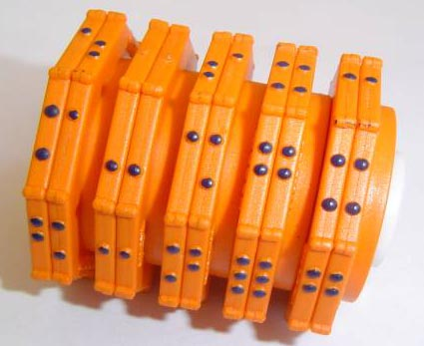  NATESAN BLOCK | 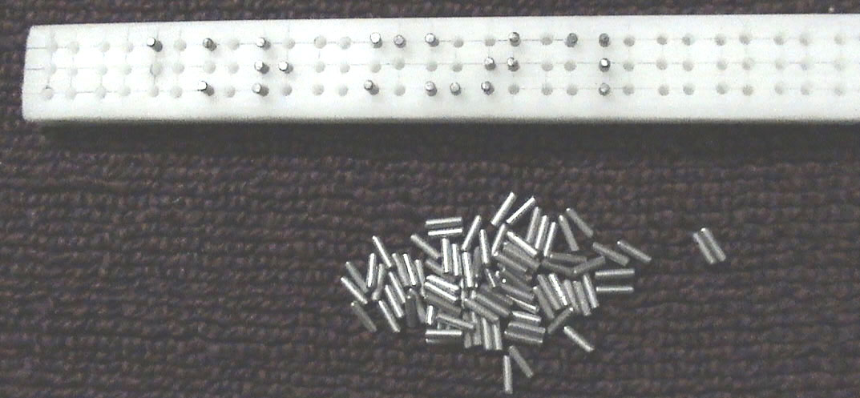  VIKAS COMPOSER | 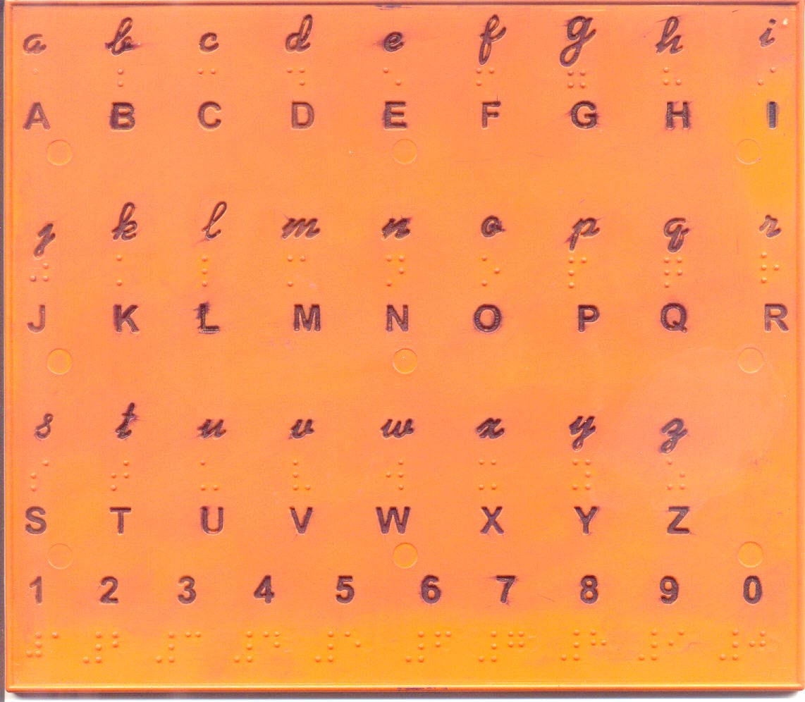  ALPHABET PLATE
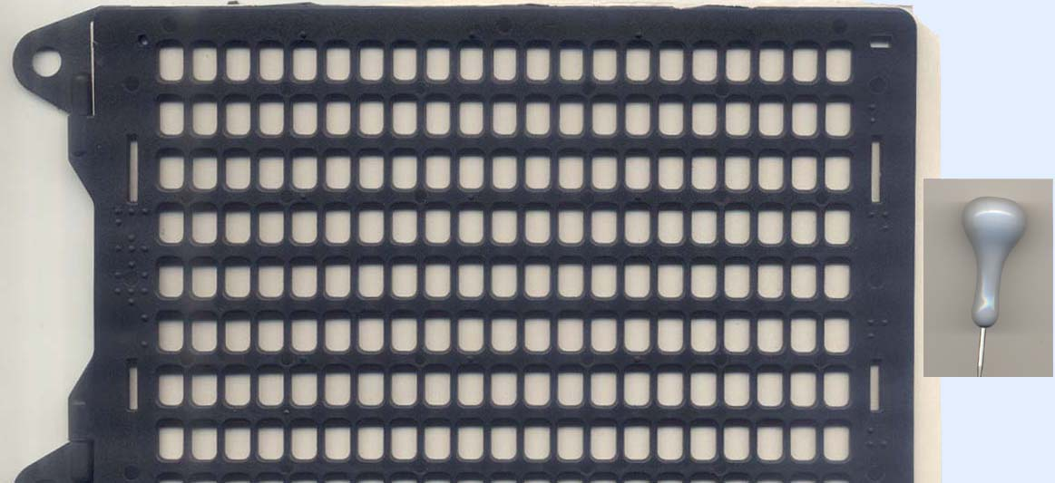  SLATE & STYLUS | 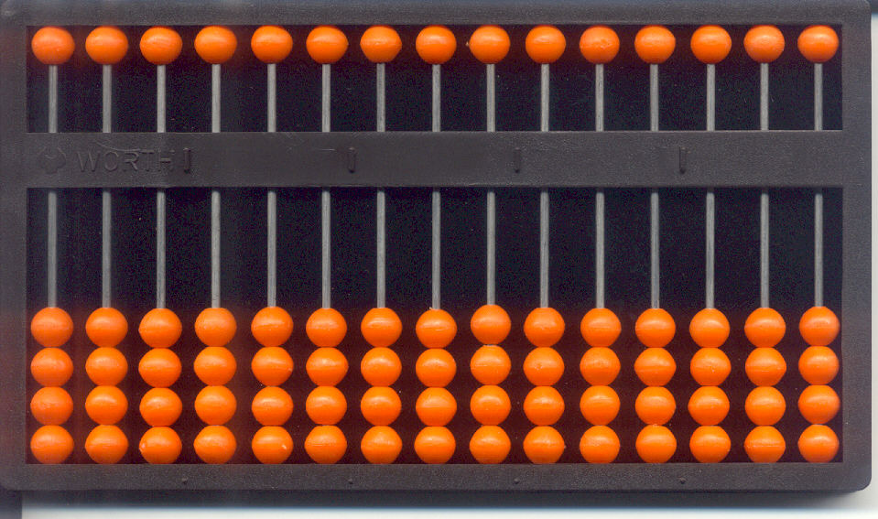  ABACUS | 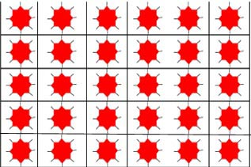  TAYLOR FRAME | 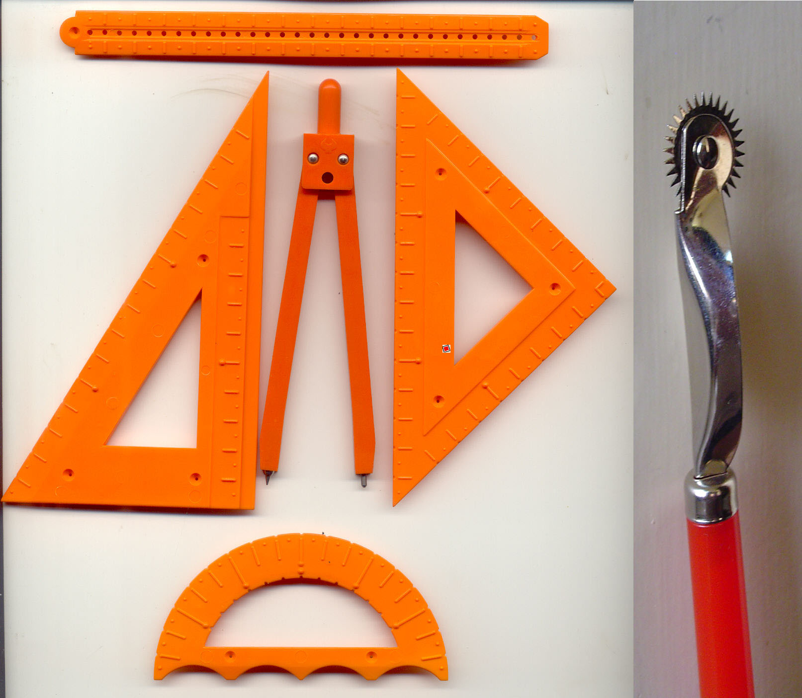  GEOMETRY BOX

While use of these devices rests primarily on the sense of touch, their design provides for concurrently exercising a wide variety of manipulative activities : turning of disks carrying dot patterns of braille letters and words in the case of (a) and (b); filling pins into hole matrices on a block to form braille sentences in the case of (c); using a stylus to punch braille dots on paper to produce readable braille text in the case of (d); following the incised letter shapes with a pencil tip to get the skills of normal handwrtiting in the case of (e); manipulating the beads on the columns and rows of the abacus or placing inserts with different directional orientation in the holes of the Taylor Frame, to develop arithmetic and mathematical concepts and skills in the case of (f) and (g); and lastly drawing and measuring different dotted lines and curves on paper in the case of (h). These manipulative processes directly reinforce whatever information is received in the centres of cognition from the sense of touch, to produce a more holistic understanding of external objects or processes. It is such a deeper understanding of this learning process that is needed in the teacher of the blind.

Many of these devices, like the Slate, Abacus, Taylor Frame and Geometry Box have long been in use. Vidya Vrikshah has contributed to new designs for the other devices, There is nothing really new or extraordinary in regard to these designs – any good designer could have designed them. But the true value of the Vidya Vrikshah contribution in this regard is three fold :
- Vidya Vrikshah has demonstrated that it is not just the trained teacher, but any literate person who can, with the help of simple user manuals provided in the local language, learn and teach braille and other skills through use of these devices. The technical mystique with which braille has been invested by so-called experts has been demolished. In fact the very rationale for special teachers and separate schools for teaching the blind is called into question. It makes a strong case for integrated schools and for greater integration of teaching skills in teachers.
- It makes the teaching of blind children possible even at the pre-school stage, by mothers, sighted siblings, relations, neighbours, social workers and volunteers. It opens the doors of literacy to large numbers of blind children who are today excluded from the school system. It provides them a start in reading and writing skills, even before entering the school system.
- All these devices have been brought together into a standard and inexpensive package, costing around Rs 450, which Vidya Vrikshah has vigorously projected for official recognition as an obligatory supply to all blind children in the country, and clearly qualifying for funding support under the Sarva Shiksha Abhiyan programme of the Government of India.

There is however a critical onward support that has to be provided as a result of establishing Braille Literacy through use of the Universal Braille Kit. Literacy gained through the Kit has to be sustained by making braille reading material available. Surely education can have no meaning unless reading material is made available in as much measure to the blind as to the sighted, but in a form suited to each. Cost is the main constraint in printing braille material – text books, magazines etc - in the large volumes needed to reach the large number of blind in the country. Low capacity braille printers cost around US$ 5,000 and high volume printers, around US$ 50,000. This puts them out of the reach of all but large governmental or non-governmental organizations with the necessary resource. And even though these capital costs may get amortised to nominal levels through large volume production, cost of the ultimate product unit, viz, the printed braille page, settles at around 2 rupees a page, mainly because of the special paper that is needed, and that accounts for the bulk of this cost. A 10 page braille magazine would thus cost around Rs 20 while a 200 page braille text book would cost Rs 400. These cost levels make for an appalling shortage in the reach of braille reading materials, specially school text books.

It is here again that Vidya Vrikshah has proposed a significant solution that makes it possible for anyone, to create the braille content that has to be printed. This is a unique IT software package, developed and offered free by the Indian Institute of Technology, Chennai. This package, the only one of its kind in the country, received the National award as the best IT solution for the disabled, in 2003. This easy to learn software enables anyone, sighted or blind, to use a computer, to create text in any Indian language, that can be produced in spoken, screen, print and braille versions. Volunteers in Vidya Vrikshah use this software to produce Dhrushti, a children’s monthly magazine in Tamil braille, which is being sent to reach children in all the blind schools of Tamil Nadu. A Kannada version is being produced and distributed likewise in Karnataka, and Telugu and Marathi versions are now under way. A simple and proven no-cost methodology for braille content creation is thus available. All that is now needed is the equipment infrastructure and the funding for the large scale printing of such material.

The points brought together in this paper, highlight the need to set the teaching of the blind child into a framework, where the spirit of integration pervades and involves every aspect of educational philosophy, psychology, policy, administration, organization and method in their impact on the learning and teaching process. All these components have been brought together in a comprehensive project formulated by Vidya Vrikshah, under the title “The National Initiative For The Blind”

---------------------------------------------------

