POLICE REFORM - 1

In the year 1969, I returned to Madras (now Chennai) from a posting in the Intelligence Bureau at New Delhi and was posted a DIG in charge of the Railways & Armed Police. The experiences that I had accumulated by that time were in-depth and wide-ranging. I had, as Superintendent of Police handled several difficult districts : Madurai, South Kanara, and Tirunelveli. I had an enormously successful five years as Deputy Commissioner of the Crime Branch of Madras City. I had spent one year setting up the Vigilance and Anti-Corruption Department of the State up and et it running smoothly. I had held charge of the Coimbatore Police Range covering six huge districts. And my last brief one year in the Intelliigence Bureau, had given me a national perspective of the politics of security and law and order. It would seem that I was destined now for a major assignment on Police Reform. But how this came out is a litlle known but intersting story.

Over the recent years I had studied the reports of Police Commissions that had been set up in several States. They had all left me quite unimpressed, as being high in homilies on improvement on the Police Image, and short on hard specifics for improving police performance. Could we do better than this, I thought, if we had a Police Commission for Tamilnadu. The more I thought about this, the more I was convinced that the idea would find a ready appeal to the sharp political instincts of M. Karunanidhi who was the then State Chief Minister. I put down the idea in a short note, in both English and Tamil that could be readily read by him, and handed it over to R.M.Mahadevan who was then tne State IGP to be passed on to the CM. In my years under him in the Madras City Police, RMM had deep trust in my judgement, and saw sense in my arguments.

It has been always my fate that whenever I offered any solution, I was invariably commissioned to implement it. And the following narrative would provide a striking illustraion. Sure enough the idea registered with the CM like a shot. And soon enough I had a call from RMM asking me to meet him with a draft of the Terms of Reference of the proposed Commission. A few days later word came that the Terms I formulated had been approved in toto and I was now asked to formulate proposals on who should head the Commission and who should be its members. My first task was now to find someone who would make a good Chairman. I suggested to RMM that HVR Iengar, ICS (Retd) who had retired as Home Secretary in the Government of India and had settled in Madras might be a good choice. RMM promptly agreed and asked me to meet HVR and prevail upon him to accept the assignment. When I met him, HVR was all courtesy and kindness but said he did not feel up to it. But, he added, there could be no better man for the job than his old friend and ICS colleague, R.A.Gopalaswami, also now retired and settled in Madras. That is how I met RAG and gained his consent to be the Chairman of the Commission. Finally, Government approved the names of RAG as Chairman, and Sivagnana Gramani, a well respected scholar-politician of Tamilnadu, Govind Swaminadhan, a retired Advocate-General and M.Chandrasekaran, a retired Civil Servant to be Members of the Commission. Predictably I landed up as the Member-Secretary of the Commission.

The Commssion sat and deliberated for the period of one year that I had proposed as time-frame for competing its work. Working with RAG who had a mind of sheer briliance and was possessed of a fantastic range of knowledge and experience in public administration, proved to one of the most enjoyable and fulfilling experiences of my life. Together we worked out the knitty gritty of the revised pay structure, and the strength and rank structure of the Tamilnadu Police Force and the mechanisms for the insulation of the force from the forces of political Intervention and Interference. The Commission left it to me to work out the knitty gritty of the Modernization strategies, which I was convinced, held the answers to the critical issues of improvement of Police Performance that affected the public most intimately from day to day. To my mind these ideas to which I gave shape and whicch were fully endorsed in the Commission are what made its Report as perhaps the first, most unique and most far-reaching documents of its kind in the field of Police Modernization in India. What it lacked in respect of other perspectives were more than offset years later in the Report of the National Police Commission, where it was left to my batchmate and inseparable part of my personality, CV Narasimhan, to produce what remain to this day, the most comprehensive and far-reaching report on Police Reform.

I shall reserve details of my work on Police Modernation for other stories to follow because they need to be told in their respective human settings. At this point, however I need to end this story with some more details of the background of this story on the Police Commission. The Report was produced in four Volumes, the first being the main narrative and the other three, substantial compilations of data to support the recommendations of the Commission. The Report had a total of 133 Recommendations

The Reports, produced in both Engllish and Tamil, wer presented to Chief Minister Karunanidhi on the 2nd January, 1971, as may be seen in th photograph below :

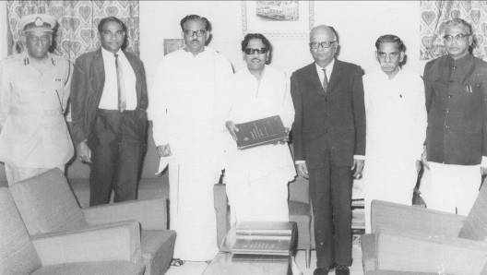

R.M.Mahadevan R.Nedunchezhian M.Karunanidhi R.A.opalaswami

E.P.Royappa M.P.Sivagnana Gramani M.Chandrasekaran

and N.Krishnaswamy (outside the picture as usual)

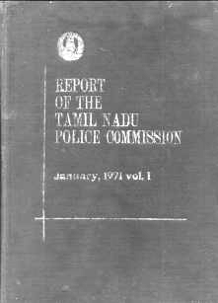 | Signed by members as below  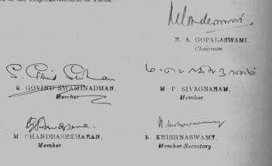

One very interesting development arising out of the Commission’s formulations on Police Modernization was how it shaped the Government of India’s thinking on this subject. The Home Ministry had begun playing with this strategy and set aside a budget of Rs 5 Crores to provide a 50 percent share to support Modernization schemes formulated by the States. Our proposal for Tamilnadu envisaged a holistic approach, spelt out in full working detail, and covering all the areas critical to the modernization process (Transport, Communications, Forensic Services, Training etc) at a cost of Rs 5 crores over a 5 year period. On behalf of the Commission, RAG and I made a trip to N.Delhi placed our proposal before L.P.Singh that awesome administrator of the ICS, who then headed the Home Ministry. But then RAG had an equally awesome reputation within the ICS fraternity and LPS listened to him with profound respect. Our simple point was that we had a comprehensive programme where each Stae would need not less than Rs crores, and therefore there was a strong case for the Government of India to raise their funding support ten fold. It is to the credit of LPS that he saw the point at once and arranged for such a hike in their funding programme from that point onwards. The result was that in the years that followed, funding for the Tamilnadu programme got guaranteed and enabled Tamilnadu to forge ahead and lead the country in the field of Police Modernization. In many ways that is an impetus that is maintained by both the Government of India and Tamilnadu to the present day.

I come now to the last point of this narrative. How about the implemention of the Commission’s Recommendations? Recommendation No. 132 proposed that a high level Committee be constituted by Government, comprised of the Chief Secretary, IGP, Home Secretary and the Finance Secretary to process and have Government orders issued on the Recommendations. And again, predictably I became the Member Secretary of this Committee. It was fortuitous that I enjoyed the personal regard and trust of both the Home Secretary S.P.Amrose, and the Finance Secretary, S.Venkitaramanan, both of them, Civil Servants of great ability and vision, and so we were able to finish processing all the recommendations in six sittings, and approve the consequent financial sanctions and the phasing of the sanctions over a 5 year period, in toto, exactly as I proposed. One final critical task remained – framing the Government order reflecting these decisions. Would you be good enough, said Ambrose to me at the end of these deliberations, to draft the GO for me ? I did accordingly frame the GO, but interestingly, in a form that required no fresh administative sanctions to issue from year to year, beyond making provision in the Departmental Annual Budget.

Thus it was that my idea of over a year ago, of a Police Commission for Tamilnadu finally caught up with me for implementing it at every step, until and includding the final step in its final sanction by the Government.
-----------------------------------------------------

